**SNS LAB 6**

**Arjun Mehta k036 B.Tech Cybersecurity Semester 3**

% Fourier Transform using Rectangular Pulse

clc;

clear all;

close all;

% Rectangular Pulse

t = -1:0.001:1;

rect_pulse = double(abs(t)<=0.5); % Rectangular Pulse

f = -50:0.1:50; %Frequency Range in Hz

% Fourier Transform using Trpz

X_f = zeros(size(f)); % Initialize Fourier Transform Result

for i = 1:length(f)

X_f(i) = trapz(t,rect_pulse.*exp(-1i*2*pi*f(i)*t));

end

%Magnitude and Phase

magnitude = abs(X_f);

phase = angle(X_f);

%Plot

figure;

subplot(4,4,1)

plot(f,magnitude);

title('Phase Spectrum of Rectangular Pulse using Trapz');

xlabel('Frequncy (Hz)');

ylabel('Magnitude');

subplot(4,4,2)

plot(f, phase);

title('Phase Spectrum of Rectangular Pulse using Trapz');

xlabel('Frequncy (Hz)');

ylabel('Phase');

subplot(4,4,3)

plot(t, rect_pulse);

title('original siganl ');

xlabel('Frequncy (Hz)');

ylabel('rectangular Phase');

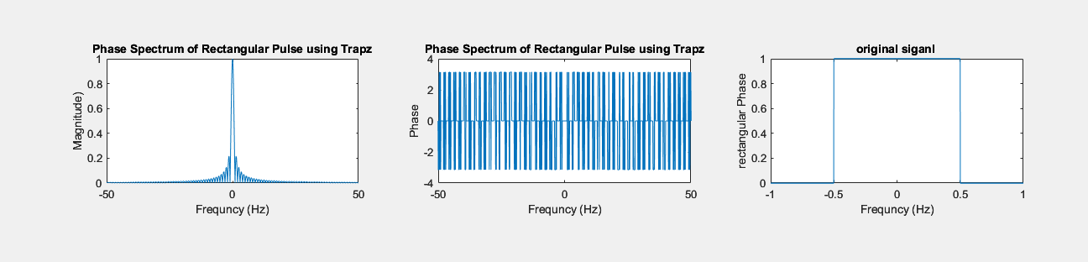OUTPUT:

clc;

clear all;

close all;

% Exponential Pulse

t = -1:0.001:1;

exp_signal = exp(-abs(t)); % Exponential Signal

f = -50:0.1:50; %Frequency Range in Hz

% Fourier Transform using Trpz

X_f = zeros(size(f)); % Initialize Fourier Transform Result

for i = 1:length(f)

X_f(i) = trapz(t,exp_signal.*exp(-1i*2*pi*f(i)*t));

% Apply trapezoidal rule

end

%Magnitude and Phase

magnitude = abs(X_f);

phase = angle(X_f);

%Plot

figure;

subplot(2,2,1)

plot(f, magnitude);

title('magnitude Spectrum of Exponential Pulse using Trapz');

xlabel('Frequncy (Hz)');

ylabel('Magnitude');

subplot(2,2,2)

plot(f, phase);

title('Phase Spectrum of Exponential Signal using Trapz');

xlabel('Frequncy (Hz)');

ylabel('Phase');

subplot(2,2,3)

plot(t,exp_signal);

title('OG signal');

xlabel('Frequncy (Hz)');

ylabel('exp_signal');

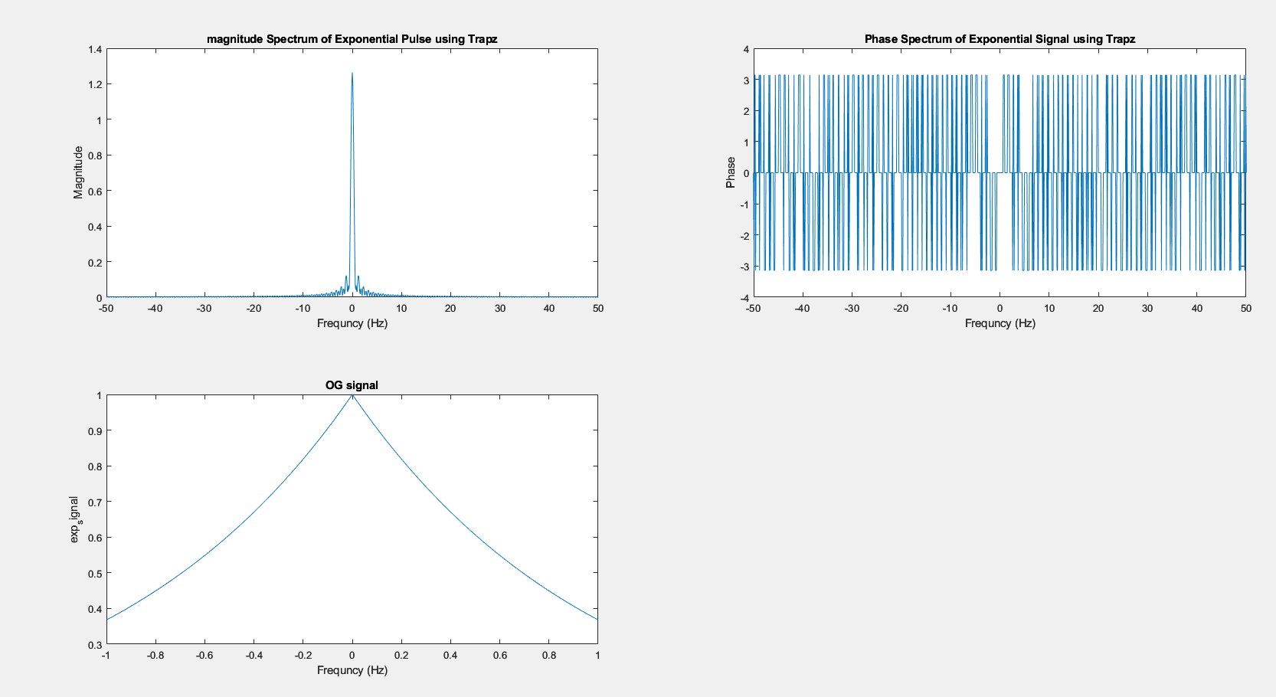

% Fourier Transform

clc;

clear all;

close all;

% Exponential Pulse

t = -1:0.001:1;

exp_signal = exp(-abs(t)); % Exponential Signal

f = -50:0.1:50; %Frequency Range in Hz

A = 15;

f1 = 10;

f2 = 15;

x1 = A*sin(2*pi*f1*t);

x2 = A*sin(2*pi*f2*t);

x3 = x1+x2;

% Fourier Transform using Trpz

X_f = zeros(size(f));

for i = 1:length(f)

X_f1(i) = trapz(t,x1.*exp(-1i*2*pi*f(i)*t));

end

for i = 1:length(f)

X_f2(i) = trapz(t,x2.*exp(-1i*2*pi*f(i)*t));

end

for i = 1:length(f)

X_f3(i) = trapz(t,x3.*exp(-1i*2*pi*f(i)*t));

end

%Magnitude and Phase

magnitude1 = abs(X_f1);

phase1 = angle(X_f1);

magnitude2 = abs(X_f2);

phase2 = angle(X_f2);

magnitude3 = abs(X_f3);

phase3 = angle(X_f3);

%Plot

figure;

subplot(4,4,1)

plot(f, magnitude1);

title('Magnitude1 Spectrum of Exponential Pulse using Trapz');

xlabel('Frequncy (Hz)');

ylabel('magnitude');

subplot(4,4,2)

plot(f, phase1);

title('Phase1 Spectrum of Exponential Signal using Trapz');

xlabel('Frequncy (Hz)');

ylabel('Phase');

subplot(4,4,3)

plot(f, magnitude2);

title('Magnitude2 Spectrum of Exponential Pulse using Trapz');

xlabel('Frequncy (Hz)');

ylabel('magnitude');

subplot(4,4,4)

plot(f, phase2);

title('Phase Spectrum of Exponential Signal using Trapz');

xlabel('Frequncy (Hz)');

ylabel('Phase (Radians)');

%ADDITION

subplot(4,4,5)

plot(f, magnitude3);

title('magnitude3 addition Spectrum of Exponential Pulse using Trapz');

xlabel('Frequncy (Hz)');

ylabel('magnitude');

subplot(4,4,6)

plot(f, phase3);

title('Phase3 addition Spectrum of Exponential Signal using Trapz');

xlabel('Frequncy (Hz)');

ylabel('Phase');

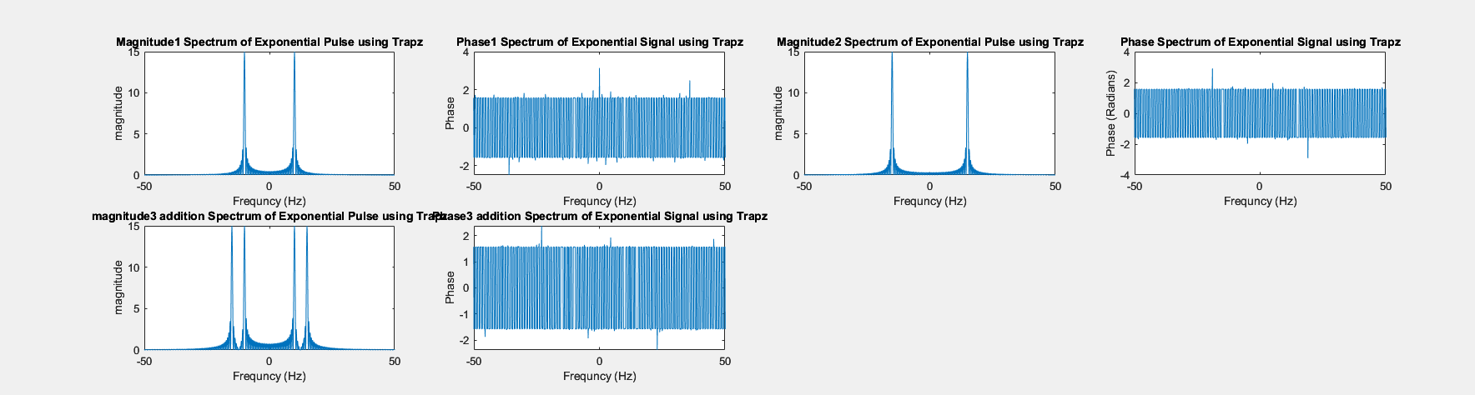

**CONCLUSION:**

RECTANGULAR ,EXPONENTIAL AND SINE WERE PLOTED;S